

THE SIMPLE PAST WITH BE
AFFIRMATIVE STATEMENTS |  |  |  | NEGATIVE STATEMENTS
I | was | a scientist |  | I | Wasn’t | a scientist
You | were | at home |  | You | Weren’t | at home
He | was | born in 2000 |  | He | Wasn’t | born in 2000
She | was | nervous |  | She | Wasn’t | nervous
It | was | noisy |  | It | Wasn’t | noisy
We | were | late |  | We | Weren’t | late
They | were | thirsty |  | They | Weren’t | thirsty

INTERROGATIVE STATEMENTS |  |  |  | YES / NO ANSWERS
Was | I | a scientist ? |  | Yes, you were |  | No, you weren’t
Were | you | at home? |  | Yes, I was |  | No, I wasn´t
Was | he | born in 2000? |  | Yes, he was |  | No, he wasn´t
Was | she | nervous? |  | Yes, she was |  | No, she wasn´t
Was | it | noisy? |  | Yes, it was |  | No, it wasn´t
Were | we | late? |  | Yes, you were |  | No, you weren’t
Were | they | thirsty? |  | Yes, they were |  | No, they weren’t

We used the simple past with be with the following complements:

- Jobs My grandfather was an excellent doctor.
- Nationalities My ex girlfriend was American.
- Places I was in China.
- Emotions My friends were happy.
- Ages She was 10.
- Adjectives My dog was so playful.
- Born. He was born in March.

Exercise 1. Fill in the blanks. Use Was /Were / Wasn’t / Weren’t.

- Mark and Susan _______________ ill yesterday.
- ________ the children in the park?
- The weather _______________ very hot last Saturday.
- I’m here today but I ___________ here yesterday.
- The kids ________________ at the theater last night.
- Betzy ________________ in France last holidays
- My father is at home now but he __________ an hour ago.
- My sister and I _______________ at the football Stadium.
- __________ it cold yesterday?
- The shops are open today but they ___________ on Sunday.

Exercise 2. Complete the text with the correct form of TO BE.

Stan Laurel and Oliver Hardy __________ two of the most popular film comedians of all time. They _________ born in 1890 and 1892 respectively.
Stan Laurel’s real name ___________ Arthur Jefferson. He _________ from England. Oliver Hardy __________ English, he _______ from Georgia, USA.
Laurel and Hardy _________ in their 30’s when they met. Their first film together _______ Putting Pants on Philip (1927). They ________ funny because they _______ so different. Lauren ______ small and thin. Hardy ______ big and fat. Their most famous films ________ Way Out West (1937) and Blockheads (1938). They _______ in any serious films, only comedies.

Exercise 3. Use the text from exercise 2 to help you to write questions for the answers.

Example: Who was Oliver Hardy’s famous comic partner? Stan Laurel

- __________________________________________ In 1890 and 1892 respectively.
- __________________________________________ Arthur Jefferson
- __________________________________________ England
- __________________________________________ No he wasn’t. He was American.
- __________________________________________ Putting Pants on Philip.
- __________________________________________ Because they were so different
- __________________________________________ Way Out West and Blockheads.
- __________________________________________ No, they weren’t. Only comedies.

THE SIMPLE PAST
AFFIRMATIVE STATEMENTS
I | visited | my grandmother yesterday
You | did | your homework two days ago.
He | washed | his dog last Monday
She | drove | her new car last weekend
It | barked | so loud last night
We | drank | coffee two hours ago
They | baked | a cake last month

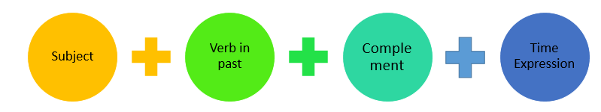

- We used the simple past to express completed actions in the past.

- We can use the following time expressions:

- Yesterday
- Last ….. week /night /Friday
- 2 days / 3 hours / 4 years … ago

- There are regular verbs, which add –ed or –d. (Check spelling rules)
- There are irregular verbs (Check the verb list)

Regular Spelling Rules.
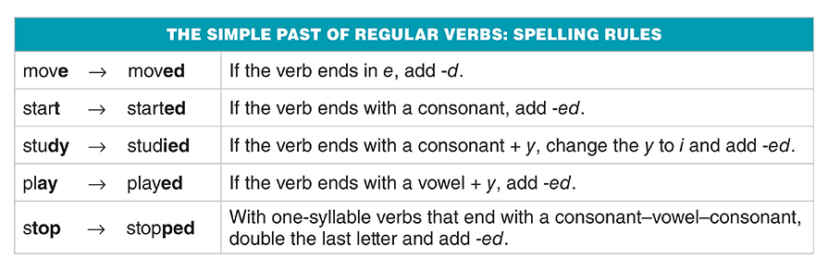

Irregular verb list.

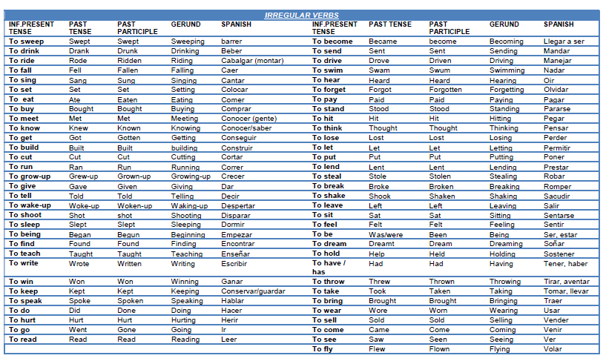

Exercise 1. Write the past tense from the following verbs.

Present Tense | Past Tense |  | Present Tense | Past tense
Do |  |  | Fry
Help |  |  | Speak
Study |  |  | Travel
Listen |  |  | Wear
Open |  |  | Sleep
Give |  |  | Know
Win |  |  | Talk
Ask |  |  | Climb
Have |  |  | Take
Come |  |  | Close
Eat |  |  | Drink
Buy |  |  | Smoke
Walk |  |  | Wash
Live |  |  | Break
Write |  |  | Rain

Exercise 2. Fill in the blanks with the Past form of the verbs.

Benjamin Franklin ___________ (be born) in Boston in 1706. He ________ (be) the fifteenth of the seventeen children of a poor candlemaker. He _________ (go) to school only one year. He _______ (begin) to work when he _______ (be) twelve. At the age of fourteen, he ___________ (decide) to be a writer. He __________ (copy) the great stories of a famous writers and later he ___________ (become) the best-known writer in his time.
When he ________(be) seventeen, he __________ (leave) Boston and ________ (arrive) in Philadelphia with only a few pennies in his pocket. He _________ (get) a job as a publisher of a newspaper and ________ (retire) forty years for his government. He ______ (play) an important role in the founding of the USA.
Franklin _________ (be) also an important scientist and inventor. He _________ (draw) electricity from a cloud on a kite string. He ___________ (write) one of the first text books on electricity. He __________ (invent) a simple lightning rod and many other practical tools. He __________ (make) a study of water and ___________ (discover) many principles of hydrodynamics. He even __________ (invent) bifocal glasses when he ________ (be) seventy eight and ________ (need) them himself.
Franklin _________ (do) all these things and many more because he ________ (believe) he ______ (can).

THE SIMPLE PAST
NEGATIVE STATEMENTS
I | didn’t | visit | my grandmother yesterday
You | didn’t | do | your homework two days ago.
He | didn’t | wash | his dog last Monday
She | didn’t | drive | her new car last weekend
It | didn’t | bark | so loud last night
We | didn’t | drink | coffee two hours ago
They | didn’t | bake | a cake last month

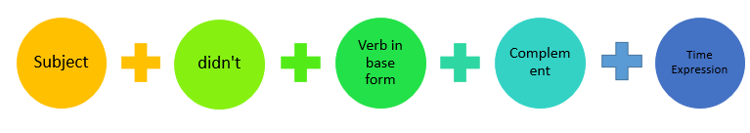
Notes:

- We use the auxiliary DID with all the subjects.

- We ALWAYS use the verb in base form in negative statements.

- It’s NOT possible to use DIDN’T + PAST TENSE I didn’t worked yesterday ×

I didn’t work yesterday √

Exercise 1. Rewrite the sentences in negative form.

- She went shopping last weekend.
__________________________________________________________________
- We cleaned the house before the party.
__________________________________________________________________
- I fed the cat 2 hours ago.
__________________________________________________________________
- I watched a film on TV last night.
__________________________________________________________________
- They visited their grandparents yesterday.
__________________________________________________________________
- My father phoned me 2 days ago.
__________________________________________________________________
- We ate popcorn yesterday.
__________________________________________________________________
- My dad took my friends and me to the circus.
__________________________________________________________________
- She saw a host last night.
__________________________________________________________________
- He broke an old chair a minute ago.
__________________________________________________________________

Exercise 2. Read the sentences and look at the word in brackets. Write true sentences.

Example: Michael Palin made a film in 1980. (TV show)
Michael Palin didn’t make a film in 1980. He made a TV show in 1980.

- He wrote “Around the world in 80 days”. (Jules Verne)
_______________________________________________________________________
- He traveled to the South Pole in 1999. (1991)
_______________________________________________________________________
- He went around the Pacific Ocean in two months. (ten months)
_______________________________________________________________________
- He walked across the Sahara Desert in 2005. (2002)
_______________________________________________________________________
THE SIMPLE PAST
INTERROGATIVE STATEMENTS |  |  |  |  | YES / NO ANSWERS
Did | I | visit | my grandmother yesterday? |  | Yes, you did |  | No, you didn’t
Did | you | do | your homework two days ago? |  | Yes, I did |  | No, I didn’t
Did | he | wash | his dog last Monday? |  | Yes, he did |  | No, he didn’t
Did | she | drive | her new car last weekend? |  | Yes, she did |  | No, she didn’t
Did | it | bark | so loud last night? |  | Yes, it did |  | No, it didn’t
Did | we | drink | coffee two hours ago? |  | Yes, you did |  | No, you didn’t
Did | they | bake | a cake last month ? |  | Yes, they did |  | No, they didn’t

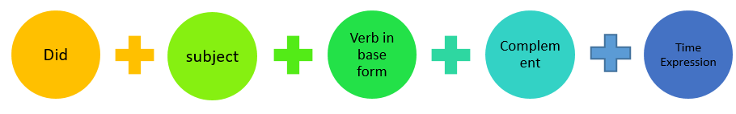

Notes:

- We use the auxiliary DID with all the subjects.

- We ALWAYS use the verb in base form in interrogative statements.

- It’s NOT possible to use DID + PAST TENSE Did you worked yesterday? ×

Did you work yesterday? √

Exercise 1. Complete the questions and answers with did or didn’t.
- A: ______ you study English at school?
B: No, I ___________.
- A: __________ you get married?
B: Yes, I _______.
- A: ______ you have children?
B: Yes, We _________.
- A: _______ Bill leave home before university?
B: No, he ________. He left home after university.

Exercise 2. Write the questions for these answers.
- ____________________________________________?
Yes, I did. I got married in 1981.
- ____________________________________________?
No, I didn’t. I met Bill after university.
- ____________________________________________?
Yes, I had a girl. Michelle is three.
- ____________________________________________?
No, I didn’t. I’m doing my homework now.
- ____________________________________________?
No, I took a taxi. It’s faster than the bus.
- ____________________________________________?
No, we didn’t. We went to France.
- ____________________________________________?
No, I didn’t. I got up early.

Exercise 3. Fill in the blanks in the correct past tense.
- Where ______________________ (she / go)?
- He _______________________ (work) in a bank.
- You ___________________ (not call) me.
- ___________________ (you /wear) your red dress?
- What _____________________ (you /do)?
- He ________________________ (not /read) that book.
- You _______________ (meet) a friend last year.
- _____________________ (she /go)?
- I _____________________ (not / forget) your book.
- She ___________________ (not / like) chocolate.
- My friend _______________ (buy) a new car last month.
- We ________________ (arrive) last night.
- ___________________ (they / come) to the party?
- They _________________ (study) last night.
- What __________________ (he /eat) pizza yesterday?
Exercise 4. Read the following story and answer the following questions.
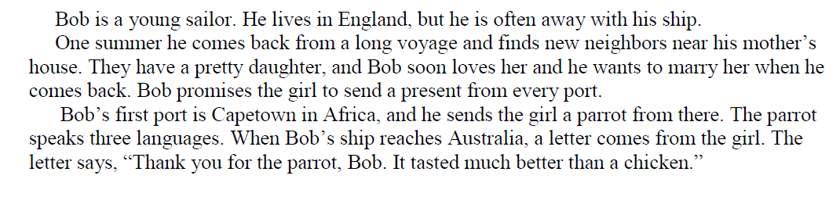
- What was Bob?
- What change did he find when he was back home?
- How was their daughter?
- How did Bob feel about the girl?
- What did Bob tell the girl?
- What did Bob send the girl from Capetown?
- Where is Capetown?
- How many languages did the parrot speak?
- What did the girl do with the parrot?
HOW MANY / HOW MUCH

- How many is used to ask about plural countable nouns.
- How much is used to ask about uncountable nouns.
- It’s common to answer a how many / how much question with a short answer.
A: How many parks are there in your city?
B: A few.
QUANTIFIERS
 | COUNTABLE | UNCOUNTABLE | EXAMPLES
+ | A lot | A lot | There is a lot of pollution
+ | A few | A little | I need a few carrots for the recipe
- / ? | Many | Much | How much money do you have?
+ | Some | Some | There is some traffic in the road
- / ? | Any | Any | Do you have any free time ?

Exercise 1. Fill in HOW MUCH or HOW MANY and the correct form of the verb to be.
- _________________ potatoes _________ there in the fridge?
- _________________ sugar would you like?
- _________________milk __________ there in the fridge?
- _________________ eggs______ there in your fridge?
- _________________ rush hour traffic _________ there in your neighborhood?
- _________________ ham _______ there in your fridge?
- _________________ large parks ________ there where you live?
- _________________ noise _______ there in your town?
- _________________ people _______ there in your city?
- _________________ taxis _________________ there in your neighborhood?

Exercise 2. Answer the questions in Exercise 1.

- ____________________________________________________________________
- ____________________________________________________________________
- ____________________________________________________________________
- ____________________________________________________________________
- ____________________________________________________________________
- ____________________________________________________________________
- ____________________________________________________________________
- ____________________________________________________________________
- ____________________________________________________________________
- ____________________________________________________________________

Exercise 3. Circle the correct answer.

- There isn’t many / any traffic on the road at the moment.
- A: How many / much friends do you have?
B: Only a few / a little. I just moved here. I only know two or three people.
- Yesterday, there was a lot of / any pollution, but today, there’s only a little / a few.
- How many / much people live in your neighborhood?
- A: How many /much bookstores are there in your city?
B: Not many /much. Most people buy books on line.
- Do you have some / any free time on the weekend?
- A: How many / much rain does this city get in the winter?
B: It gets a lot / much.

LIKE AND WOULD LIKE
AFFIRMATIVE STATEMENTS (LIKE) |  |  |  | AFFIRMATIVE STATEMENTS (WOULD LIKE)
I | like | to swim /swimming |  | I | would like | to be a pilot
You | like | to drive /driving |  | You | would like | to study French
He | likes | to play / playing |  | He | would like | to buy a car
She | likes | to travel / traveling |  | She | would like | to have a boyfriend
It | likes | to run / running |  | It | would like | to walk around
We | like | to cycle /cycling |  | We | would like | to go on holidays
They | like | to read / reading |  | They | would like | to watch a film

NEGATIVE STATEMENTS (LIKE) |  |  |  | NEGATIVE STATEMENTS (WOULD LIKE)
I | don’t like | to swim /swimming |  | I | Wouldn’t like | to be a pilot
You | don’t like | to drive /driving |  | You | Wouldn’t like | to study French
He | doesn’t like | to play / playing |  | He | Wouldn’t like | to buy a car
She | doesn’t like | to travel / traveling |  | She | Wouldn’t like | to have a boyfriend
It | doesn’t like | to run / running |  | It | Wouldn’t like | to walk around
We | don’t like | to cycle /cycling |  | We | Wouldn’t like | to go on holidays
They | don’t like | to read / reading |  | They | Wouldn’t like | to watch a film

INTERROGATIVE STATEMENTS (LIKE) |  |  |  | YES / NO ANSWERS
Do | I | to swim /swimming? |  | Yes, you do |  | No, you don’t
Do | you | to drive /driving? |  | Yes, I do |  | No, I don’t
Does | he | to play / playing? |  | Yes, he does |  | No, he doesn’t
Does | she | to travel / traveling? |  | Yes, she does |  | No, she doesn’t
Does | it | to run / running? |  | Yes, it does |  | No, it doesn’t
Do | we | to cycle /cycling ? |  | Yes, you do |  | No, you don’t
Do | they | to read / reading? |  | Yes, they do |  | No, they don’t

INTERROGATIVE STATEMENTS (WOULD LIKE) |  |  |  | YES / NO ANSWERS
Would | I | to be a pilot? |  | Yes, you would |  | No, you would n’t
Would | you | to study French? |  | Yes, I would |  | No, I would n’t
Would | he | to buy a car? |  | Yes, he would |  | No, he would n’t
Would | she | to have a boyfriend? |  | Yes, she would |  | No, she would n’t
Would | it | to walk around? |  | Yes, it would |  | No, it would n’t
Would | we | to go on holidays? |  | Yes, you would |  | No, you would n’t
Would | they | to watch a film? |  | Yes, they would |  | No, they would n’t

- We use like to talk about things you enjoy doing in general. The infinitive (to + verb) or the gerund (-ing form) is used after like.

- We use would like to talk about specific things you want to do in the future. The infinitive (to + verb)is used after would like.

- The contracted form of would like is ‘d.

Exercise 1. Choose the correct word or phrase to complete each sentence.
- I like / would like to visit Australia next year.
- Jordan likes / would like to eat much candy.
- Harry likes / would like to work in a different company.
- We like / would like to see movies on the weekends.
- Mary likes / would like to get into better shape this year.
- My parents like / would like to move to a smaller house.
- Simon likes / would like to go running on Sundays.
- They like / would like to study in a foreign University.
- Alexa likes / would like playing chess.
- I don’t like / wouldn’t like to eat salty food.

Exercise 2. Use the words in the box to complete the conversations.

I like do you like I’d like
I don’t like do you like I’d like
You’d like would you like I’d like

A: This menu looks interesting. ____________________ to try something new, but I can’t decide.
B: Well, what kind of food _________________?
A: Let’s see… ______________anything to strange, but _____________ spicy food.
B: Then I think ____________ the red curry. It’s really spicy… and very delicious!
A: It sounds good. I think _____________ that.

A: What changes. _________________ to make in the new year?
B: Well, for one, __________________ to lose some weight. I’m out of shape.
A: I see. And, ________________ to exercise?
B: Yes, I do.
A: Come with me to the gym tomorrow, then. We can work out together.
PLASTIC HABIT VOCABULARY.

BODY PARTS VOCABULARY
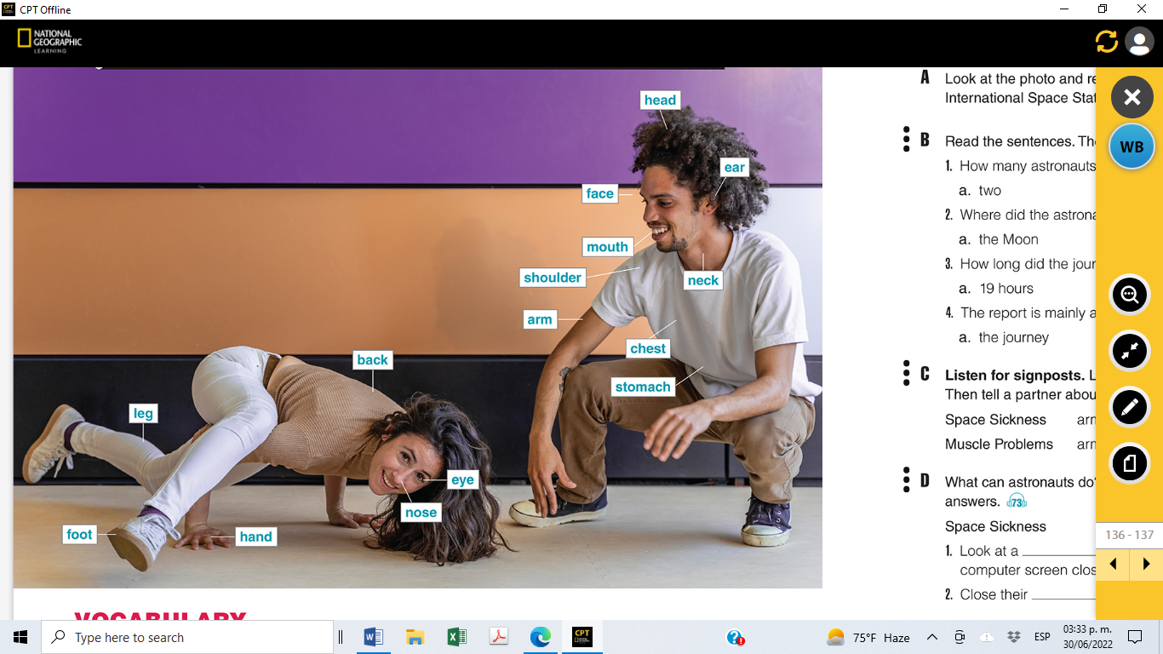

SPORTS VOCABULARY
